2.2 Empathy Map Template
The source project document provides an Empathy Map Template for ComicCraft to understand the intended user's needs, experiences and difficulties.
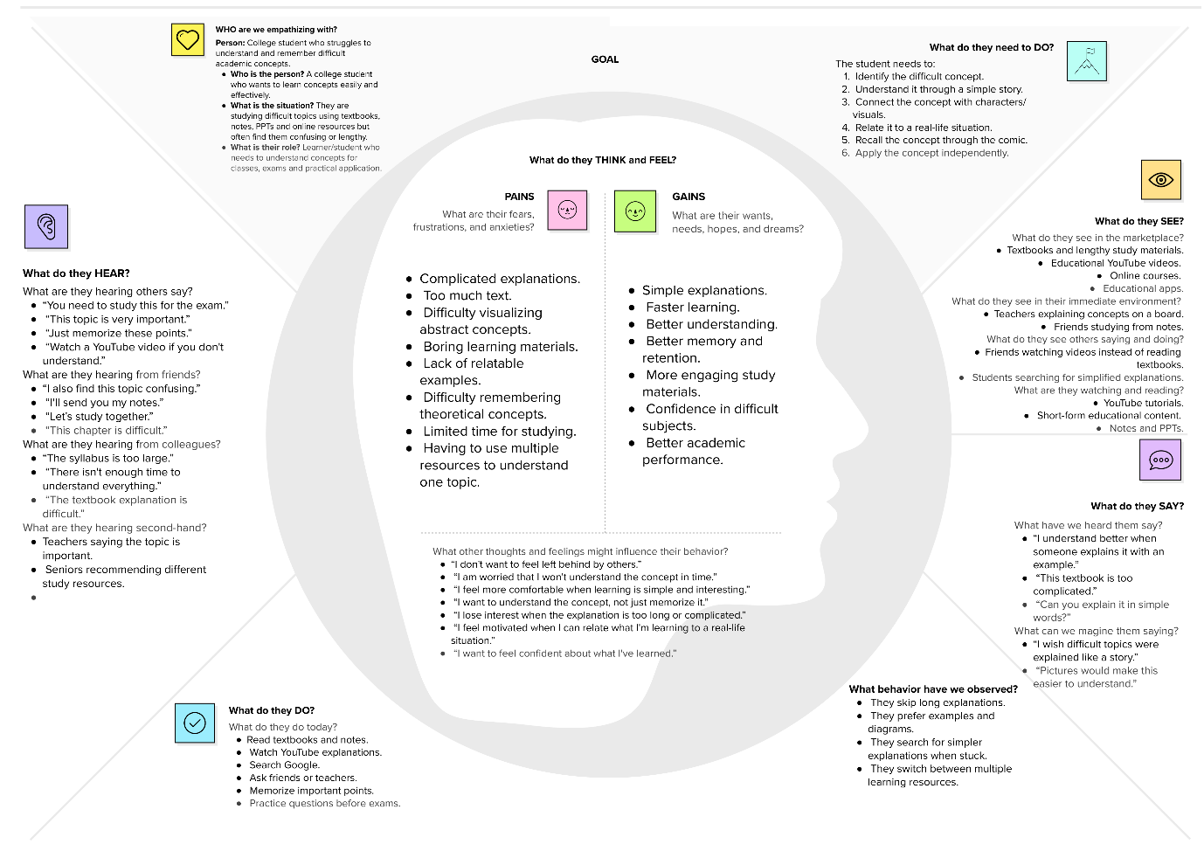
Empathy Map

